AICCSA 2018 Venue 28th Oct to 1st Nov 2018, Aqaba, Jordan

AICCSA 2018 will take place in the beautiful city of Aqaba, Jordan at the Luxury 5* Hotel -InterContinental -Aqaba (Resort Aqaba) (Click here). The Luxury Red Sea Resort with a private Beach, is right in the centre of the City of Aqaba and is only 10 minutes trip to Aqaba (King Hussein) Airport.
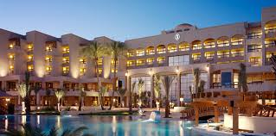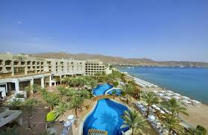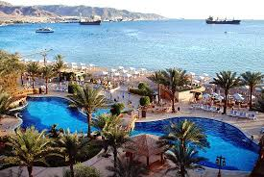

There are direct flights to Aqaba from the following Cities:
Sofia, Bulgaria
Amman, Jordan
Istanbul, Turkey
Cairo, Egypt
Cologne, Germany
Athens, Greece
Rome, Italy

If you fancy a beautiful, inspirational road trip, full of history, you can either take a taxi (group is advised to share the cost) or take public transport (Modern Buses with Aircon). You can also rent a car at the airport.

For more information about the city of Aqaba and Jordan, please do visit:
www.visitjordan.com/
We have negotiated very good rates for the hotel rooms for all AICCSA 2018 participants, with a rate of 85JD ($120) per night including Breakfast (Single Occupancy) and 90JD ($130) per night including breakfast (double occupancy). A link will be provided on this page shortly, where you can make your reservations, so please keep an eye on this page. Also a reminder email will be sent to all authors, once it is updated.
For convenience we advise all participants to stay at the conference Hotel, especially with the discounted rate of almost 40%. However, there many other hotels, few minutes’ walk to conference Venue, which you can stay at, with room rates starting from $45 per night per room.

Yafko ***

Al Qidra ***

Days Inn Aqaba ***

Summer Bay Resort ***

Golden Tulip Aqaba ****

DoubleTree by Hilton Aqaba****

Kempinski Aqaba *****

